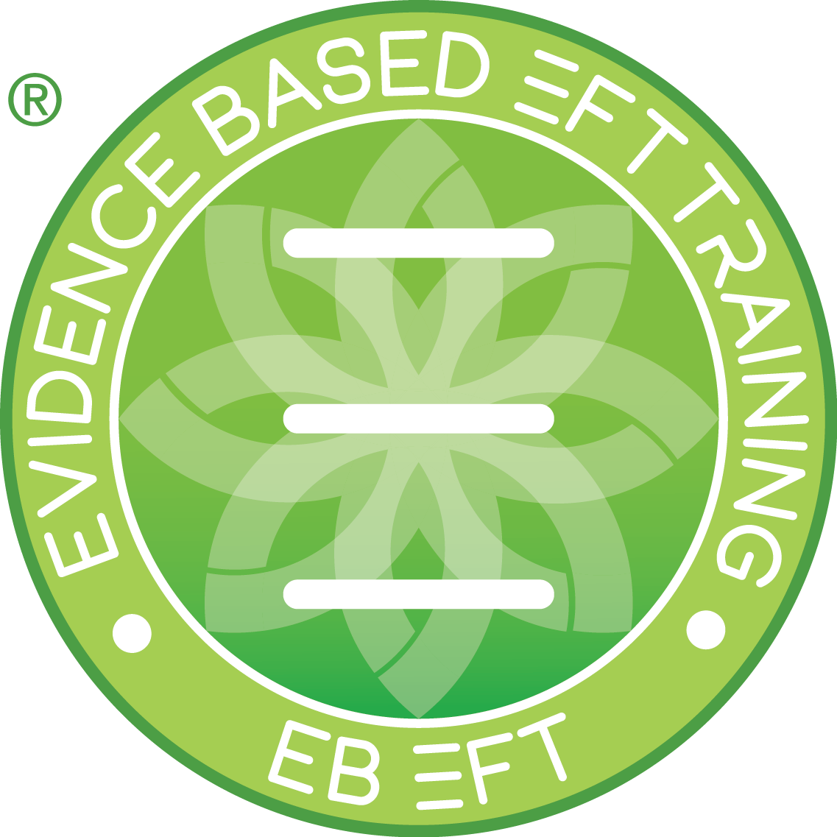
Tapping Self Work Log & Notes

EBEFT Trainee | EBEFT Trainers / Mentors | Date Submitted

Please provide an overview of the 3 x 1-hour sessions you had as a client with an approved (Checked with mentor ) certified/accredited practitioner who ideally is not one of the mentors.

Name of Practitioner(s) __________________________ ________________________ __________________
Focus for session 1  Insights gained that may help me as a practitioner: | SUD Start | SUD End
Focus for session 2

Insights gained that may help me as a practitioner:

Focus for session 3

Insights gained that may help me as a practitioner:

Please provide an overview of the 5 x 1-hour swap sessions you had (discuss here the work you did as a client)

Focus for session 1  Insights gained that may help me as a practitioner: | SUD Start | SUD End
Focus for session 2

Insights gained that may help me as a practitioner:

Focus for session 3

Insights gained that may help me as a practitioner:

Focus for session 4

Insights gained that may help me as a practitioner:

Focus for session 5

Insights gained that may help me as a practitioner:

Please provide an overview of the 5 x self-tapping sessions (minimum 30 minutes each)

Focus for session 1  Insights gained that may help me as a practitioner: | SUD Start | SUD End
Focus for session 2

Insights gained that may help me as a practitioner:

Focus for session 3

Insights gained that may help me as a practitioner:

Focus for session 4

Insights gained that may help me as a practitioner:

Focus for session 5

Insights gained that may help me as a practitioner:

