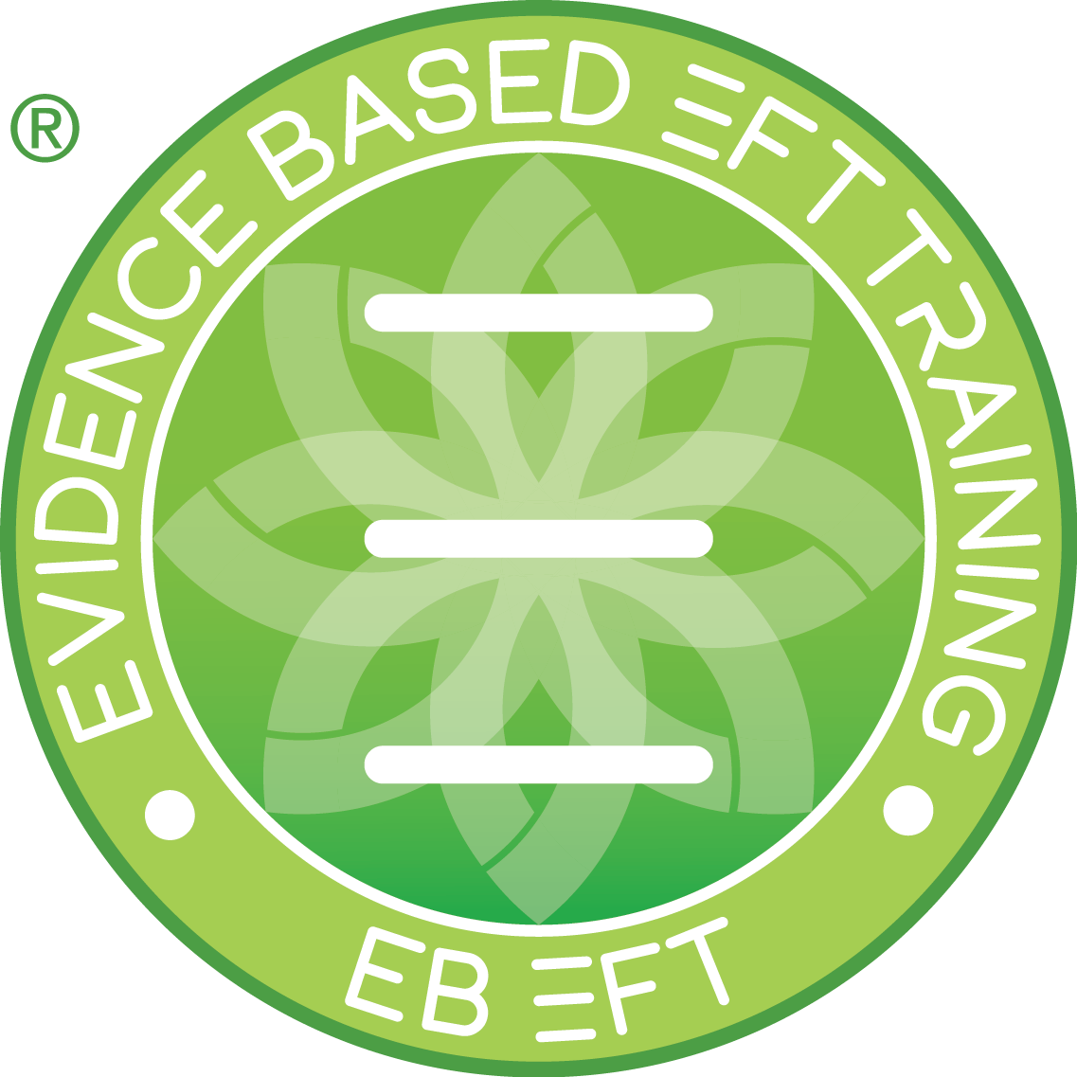
Tapping Self Work Notes

EBEFT Trainee | EBEFT Trainer / Mentor | Date Submitted | Session # (of 13)

Please provide an overview of the 3 x 1-hour sessions you had as a client with a certified practitioner who is not the mentor
Focus for session 1 | SUD Start | SUD End
Focus for session 2

Focus for session 3

Please provide an overview of the 5 x 1-hour swap sessions you had (discuss here the work you did as a practitioner)

Focus for session 1 | SUD Start | SUD End
Focus for session 2

Focus for session 3

Please provide an overview of the 5 x self-tapping sessions (minimum 30 minutes each)

Focus for session 1 | SUD Start | SUD End
Focus for session 2

Focus for session 3

